**System and its stability**

**Lab report #03**



Fall 2022

CSE-310L Control Systems

Submitted by: **Ashfaq Ahmad**

Registration No: **19PWCSE1795**

Class Section: **B**

“On my honor, as student of University of Engineering and Technology, I have neither given nor received unauthorized assistance on this academic work.”

Student Signature: ______________

Submitted to:

**Dr: Muniba Ashfaq**

**Oct** 28, 2022

**Department of Computer Systems Engineering**

**University of Engineering and Technology, Peshawar**

**System**

* Collection of different components or sub-systems which takes input x, process it and give output as y.
* Collection of constants and variables which takes input, process it and then give output.
* A system gives desired output on desired input is called **control system**.

**Poles:**

* Poles are the of roots of denominator of transfer function.
* Poles find the stability of a system.

**Zeros:**

* Zeros are the roots of numerator of transfer function

**Stability of Control System**

The stability of a control system is defined as the ability of any system to provide a bounded output when a bounded input is applied to it

Types of systems on the basis of stability.

1. **Stable system:**

* When the poles of the transfer function of the system are located on the left side of the s-plane then it is said to be a stable system.
* Real part of al roots must be negative or combination of negatives plus zeros. No matter what the imaginary part is.
* However, as the poles progress towards 0 or origin, then, in this case, the stability of the system decreases.
* Graph of stable system reaches to certain constant value as time axis increase.

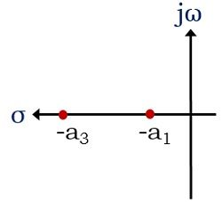

1. **Marginally stable:**

* For marginally stable the roots must lying on imaginary axis I,e the real part of all roots must be zero.
* There exist two conditions for the poles that are present in the imaginary axis:
* Graph of stable system neither increase nor decrease but vibrates between two fixed points as time axis increase.

1. If for a system, the poles are present in the imaginary axis and are non-repetitive in nature, then it is said to be a **marginally stable system**.  
   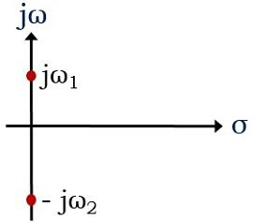
2. However, if there exist repetitive poles in the imaginary axis of the s-plane. Then it is called to be an **unstable system**.  
   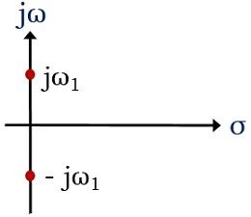
3. **Unstable system:**

* If even one pole of the transfer function of the system is located on the right side of the s-plane then it is said to be an unstable system.
* Real part of at least one root must be negative for unstable system. No matter what the imaginary part is.
* However, as the poles progress towards 0 or origin, then, in this case, the stability of the system Increase.
* Graph of unstable system reaches to infinity as time axis increase.

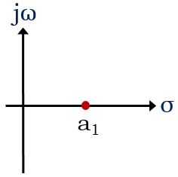

**Task:** Design three systems (both in matlab code and Simulink) with complex poles such that first is stable, 2nd is unstable and 3rd is marginally stable. Show the results graphically.

**Stable system:**

System=30/x2+5x+10

**Code:**

clc

clear all

close all

num=30;

denum=[1 5 10];

r=roots(denum)

sys=tf(num,denum);

figure

pzmap(sys,'r');

step_response=step(sys);

figure

plot(step_response);

xlabel('time');

ylabel('Amplitude');

title('stable Function');

**Output:**

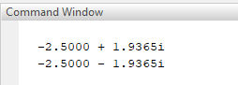

**Plot of poles:**



**Graph of step response of stable system**



**Block diagram**

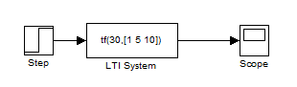

**Graph:**

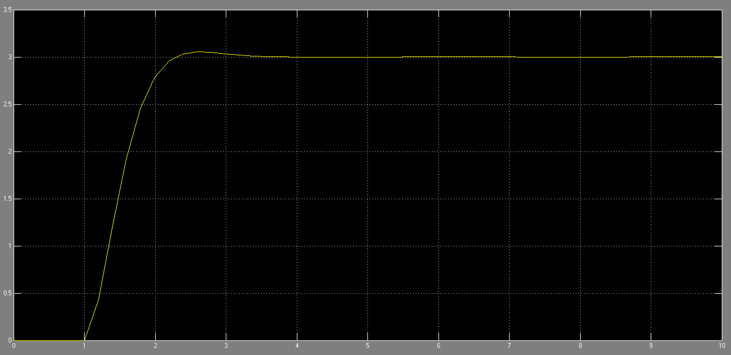

**Marginally Stable system:**

System=30/x2+10

**Code:**

clc

clear all

close all

num=30;

denum=[1 0 10];

r=roots(denum)

sys=tf(num,denum);

figure

pzmap(sys,'r');

step_response=step(sys);

figure

plot(step_response);

xlabel('time');

ylabel('Amplitude');

title('Marginally stable Function');

**Output:**

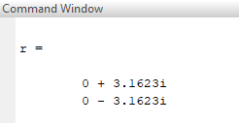

**Plot of poles:**



**Graph of step response of marginally stable system**



**Block diagram**

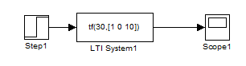

**Graph:**

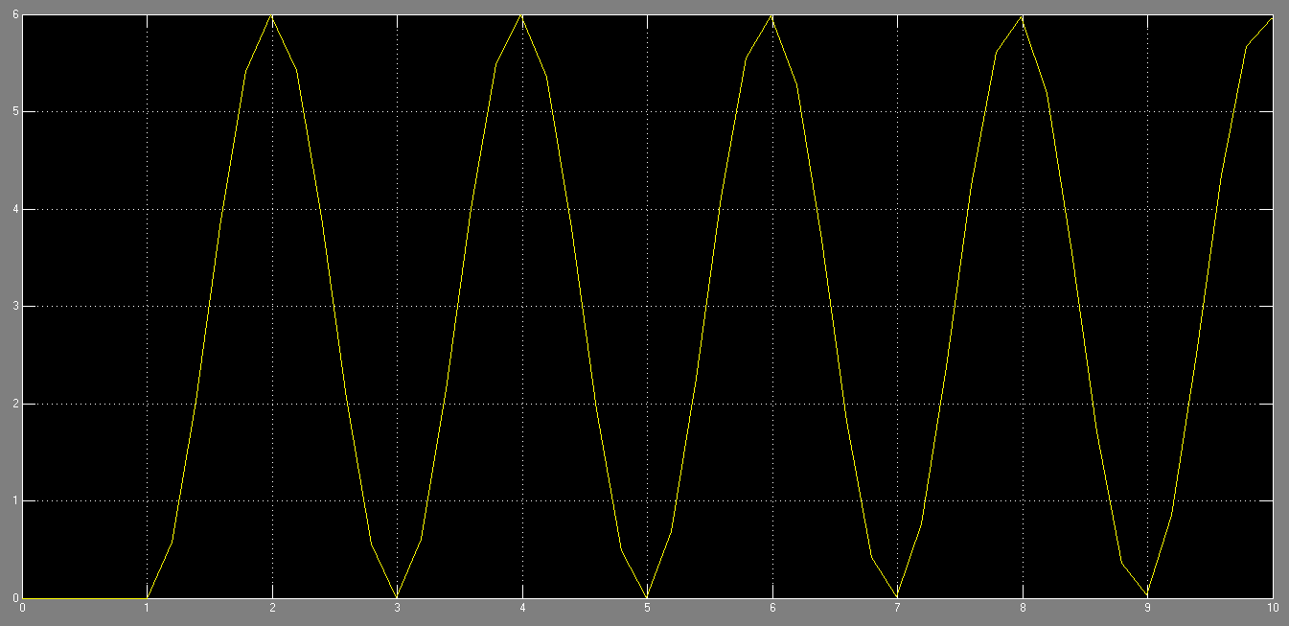

**Unstable system:**

**Code:**

clc

clear all

close all

num=30;

denum=[3 -2 10];

r=roots(denum)

sys=tf(num,denum);

figure

pzmap(sys,'r');

step_response=step(sys);

figure

plot(step_response);

xlabel('time');

ylabel('Amplitude');

title('Unstable System');

**Output:**

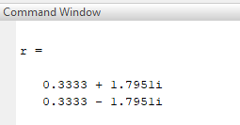

**Plot of poles:**



**Graph of step response of unstable system**



**Block diagram**

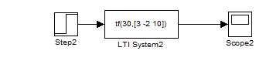

**Graph:**

